|  |  |  |  |
| --- | --- | --- | --- |
| Name:  Class: | ____________________________________  ________________ | | Date: ___________ |
|  | **Year 11 Essential Mathematics Unit 2**  SCORE:  / 26    **Mini Test 2.1 2018**  **Topic – Data analysis and Displays**  ***Full working out MUST be shown to get full marks for each question.*** | | |
| **Total Time:** | 30 minutes |  | |
| **Weighting:** | 1% |
| **Equipment:** | To be provided by the student: Pen, pencil, ruler, scientific calculator,1 single sided page of A4 notes | | |

**Question 1**

The shapes of the graphs below can be described using the words “positive Skew”, Negative Skew”, “symmetrical” and “Bimodal”. Underneath each graph, write the most appropriate term. **[3 marks]**

1. 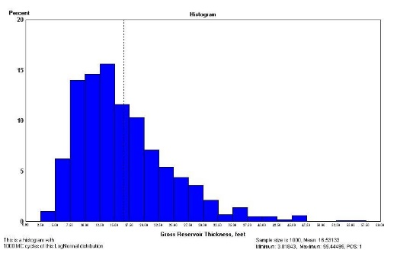 B)

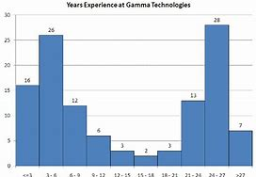

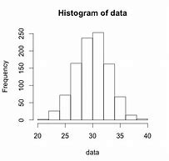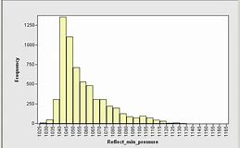

C) D)

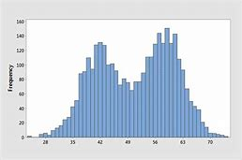 E) F)

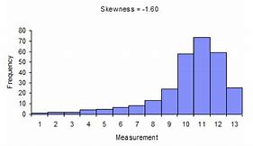

**Question 2**

These are the waiting times (in minutes) for the service when calling customer service of two phone companies:

Telstra: 10, 7, 6, 8, 7, 5, 6, 9, 7, 3, 8, 8, 9, 7, 9, 7, 9, 8

Vodafone: 10, 5, 9, 9, 9, 10, 11, 9, 8, 7, 9, 7, 7, 6, 8, 11, 11

1. Find the 5 Number Summary for each data set. **[5 marks]**
2. Construct a box and whiskers plot for each data set on the same number line below.

**[10 marks]**



1. Telstra claims that its waiting times are generally lower than those of Vodafone. Using the data, explain whether Telstra’s claim is correct. **[3 marks]**

**Question 3**

The data below is information about the number of hours worked over 2 weeks by different employees at Built Fast Enterprises.

|  |  |  |
| --- | --- | --- |
| Week 2 Data |  | Week 1 Data |
| 9 | 0 | 6, 7, 9 |
| 9, 7, 6, 6, 5 | 1 | 3, 7, 9, 9 |
| 9, 9, 9, 4, 3 | 2 | 4, 9, 9 |
| 9, 5, 5, 4 | 3 | 3, 5, 7, 8 |
| 1, 1 | 4 | 0, 2, 6 |
| 5, 1 | 5 |  |
|  | 6 | 0, 2 |

1. Find the mean, median and mode for each week. **[3 marks]**

1. Using the data provided, explain which week the employees of Build Fast Enterprises were most productive. **[2 marks]**

**End of Test**